Setting Up Events in Eventbrite Template
This document has been prepared to assist the organising committee to make the key decisions required for the event set-up. The template will also assist the business office to ensure the event set up is made in accordance with instructions of the event organising committee in a timely manner.
Document Key: this will help you navigate through the document
- Background information will be in grey text.
- Required information will be in green boxes.
- Examples will be in blue text

Event Title
The Event Title is the first thing the registrant will see on the page. It needs to be clear and interesting.
Examples Include: Uncover Curnamona 2017, Core Logging Workshop, GSA QLD Esk Valley Excursion…
Title:

Location
This should be the location of the event (if participants meet at the location) or the pick-up point (if participants will be boarding a bus that is provided).
Name of Venue:
Address:
Suburb:
State: Post Code:

Banner Image
Image should be a high resolution - recommend using at least a 2160 x 1080px (2:1) image no larger than 10MB. Careful consideration should be given to the event image to ensure its appealing to participants. Image should be in .jpg. Email this as a separate .jpg file.
Provide at least two event images to: tim.holland@gsa.org.au
Good examples of some images: landscape or location-based mages or research-based images 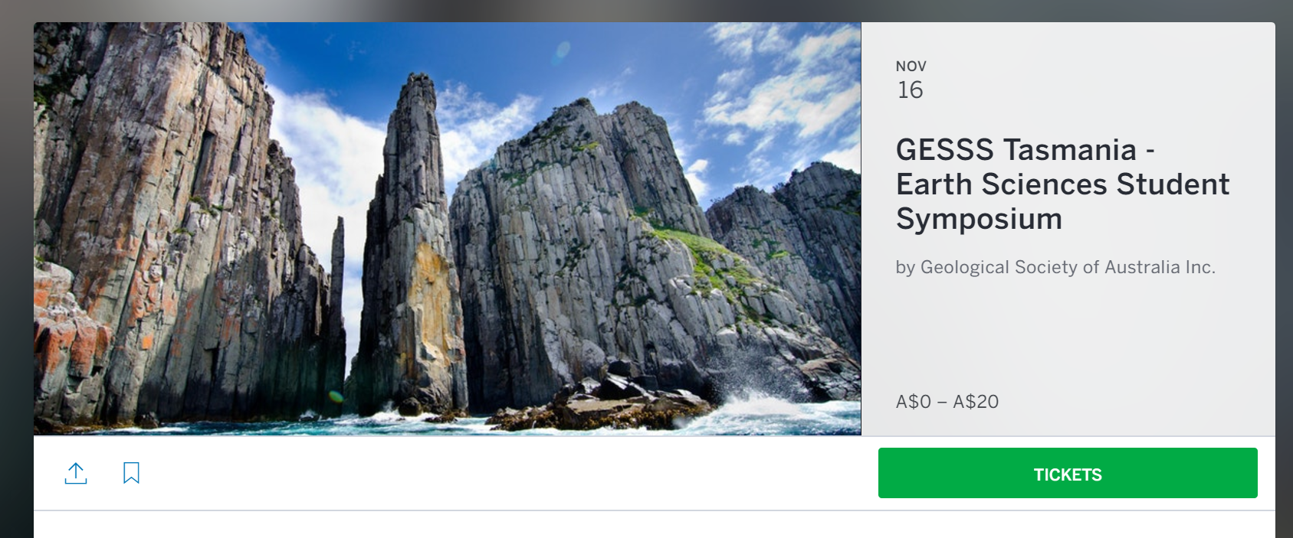

Event Start date and time & Event End date & time
Example:
Start Date: End Date:
Time: Time:

Event Description
This section can include text and an image/s (e.g. logos) that describe the event.
Examples: Image & Text – Simple but effective. Could include website link.
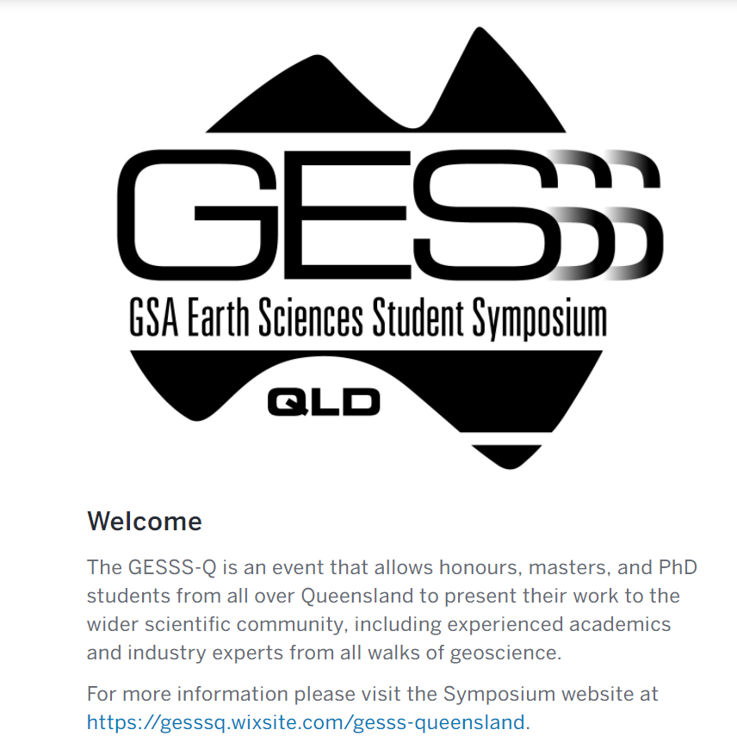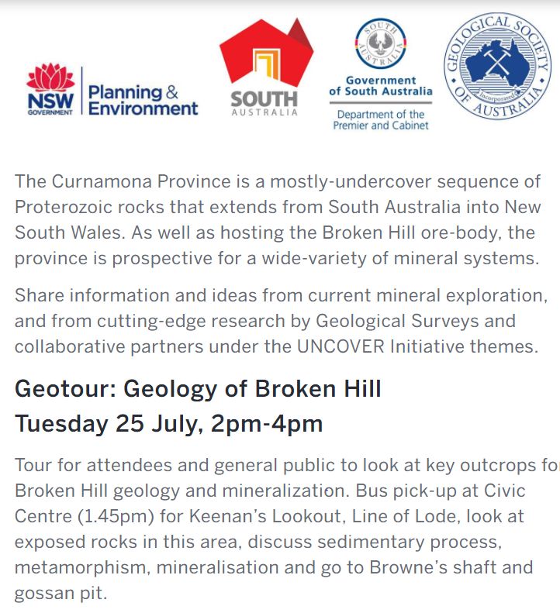
** Please email separately any images or logos to tim.holland@gsa.org.au (if not using the GSA logo).
Event Description Text:

Organiser Name
This is usually the organisation that is organising the event.
Examples: Single Organisation Event Multi Organisation Event
Organisation organising the event:

Event Type
Appearance & Signing Attraction Camp, Trip or Retreat
Class, Training or Workshop Conference Convention
Dinner or Gala Other Meeting or Networking Event
Seminar or talk
Event Type: E.g. Dinner (please pick and insert appropriate event type from above list)

Waivers
Waivers are important when participants attend field trips etc. The waiver can be edited to include content that is required. ** The waiver question on the Eventbrite registration should not be relied upon 100%. We require an additional waiver to be signed by the participant on the day of the field trip.
Example of a Waiver used:
This trip is being undertaken of your own free will. The Geological Society of Australia accept no liability for any injury or damage to property suffered during this excursion. Please do not hammer, damage, climb on or disturb the rock faces and local vegetation.
By registering I confirm that I will follow the instructions of the field leader and neither I or a member of my group will engage in at-risk behaviour.
Is a Waiver Required: Yes / No If Yes please specify content of waiver below.
Waiver:

Ticket Types
Creating the correct ticket types is a key area for setting up an event. Some considerations when deciding the ticket types include:
- Is there a fee involved to register, if so how much?
** Eventbrite charges an administration fee of 4.5% of revenue plus A$0.99c per ticket for paid tickets. These fees are subject to change by Eventbrite. Free events have no Eventbrite fees.
- Does one price apply to all registrants? Or are there different prices applicable to registrants?
- Do we want to restrict the quantity of tickets to a particular category of registrant?
- Does the event include discounted prices for early-bird registrations?
- Does the event include program items which registrants may register separately?
Example 1: Simple – One ticket option with
no fee
– Free Event with no different category
for registrants.

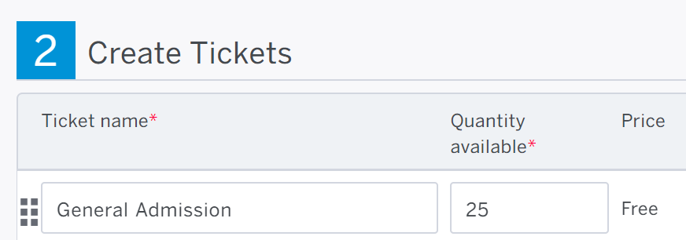
Example 3: Early-bird Registration versus Normal Registrations
Early-bird tickets can be created by setting times when certain ticket types are available for purchase. Ticket sale dates for early-bird tickets would begin and end before regular ticket sales. Example below:
Ticket Type | Price | Ticket Sale Start | Ticket Sale End
Early-bird Member Ticket | $100 | 9/08 | 15/09
Regular Member Ticket | $150 | 16/09 | 23/10

Example 4: Quantity Allocation of tickets
Tickets quantities can be vairied by ticket type to ensure a target audience attends an event. See below where more tickets are available for students/early careerists and underemployed geoscientists 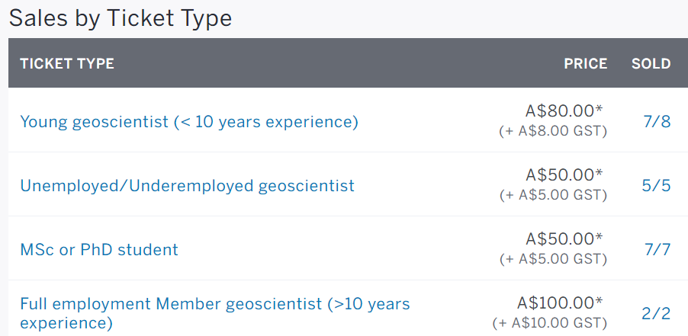
** Ticket type quantity allocation can be amended at any time

Example 2: Simple – Ticket with a fee and two categories of registrants – Full Member & Student or retired member – here you can see different prices are being charged depending on your category. 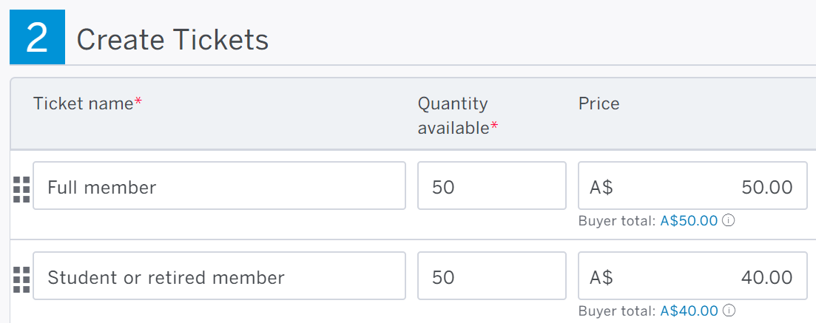

Example 5: Multi-day Event Set up
In the example, each program item occurs on separate day days and has separate ticket type.
+ Geotour – 25 July 2017 – Simple ticket type
+ Symposium – 26 July 2017 – Included 3 types options: Self-drive, Adelaide Bus and Sydney Bus (fee)
+ Field trip – 27 July 2017 – Simple ticket type
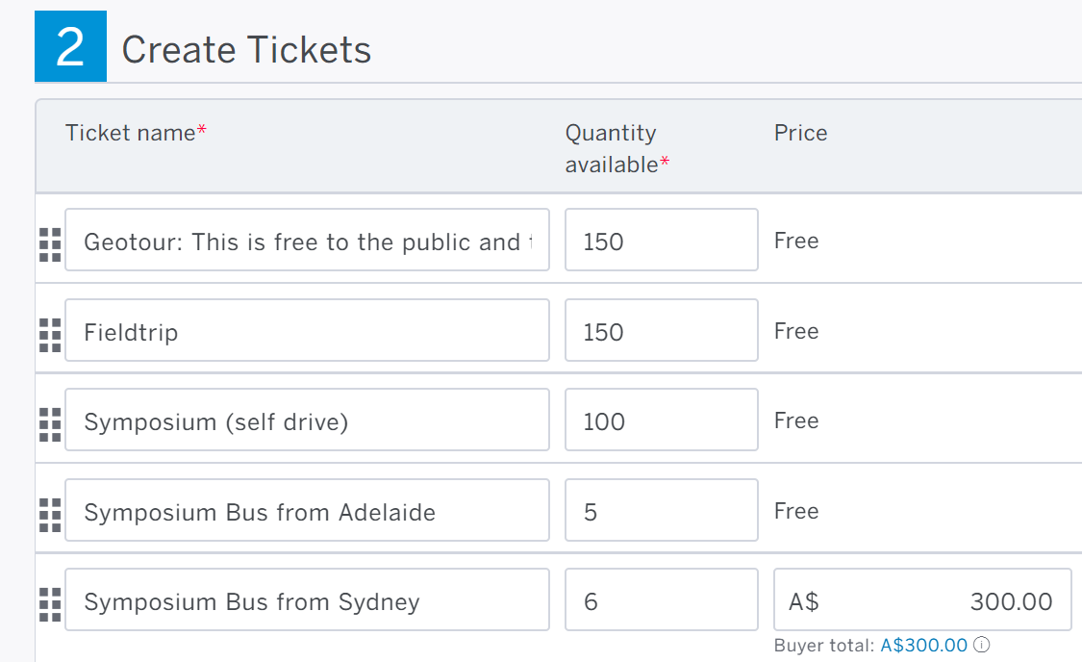
If a member wanted to attend all three program items they would register for 1 ticket for the Geotour, 1 ticket Field trip and 1 ticket for Symposium ticket option.
Setting up ticket types.
- Determine whether it’s a free or paid ticket
- Ticket name – this should clearly outline the ticket being purchased by the registrant
- Quantity available for ticket type/s
- Ticket Price – We set up the ticket prices including Eventbrite fees and GST. Provide the ticket price including GST of 4.5% of revenue plus A$0.99c per ticket
- Explanation of the ticket type. E.g. Self-drive Symposium ticket for Uncover Curnamona included the ticket description: “You will need to organise your own travel to/from Broken Hill and accommodation in Broken Hill”.
- Ticket sale start and end dates and times (consider different dates for early-bird tickets).
** It is important to plan ahead and determine a cut-off time for registrations to close in case you need to organise transportation, print name badges, have sufficient promotional giveaways etc.
- Ticket number allowed per order, e.g. can one registrant register for 5 of the same ticket types on behalf of other people or must each registrant register separately.
Refund policy – this will appear at the bottom of the event description.
Registration fees may be refunded up until the close of the registration sales. After this date no refunds will be given except in the event that the conference is significantly changed or cancelled. Refunds are of event entry fees only, and not of other costs that may be associated with the event, such as accommodation and travel. Refund requests should be directed to sgtsg2019@gmail.com and will be responded to within 5 business days.
Refund policy:

Your Ticket Type
Ticket Type #1
# | Set Up Questions | Answers
1 | Free or Paid ticket
2 | Ticket name
3 | Quantity available
4 | Price of ticket (n/a if free)
5 | Explanation of ticket type
6 | Ticket description to be displayed on ticket (Yes/No)
7 | Ticket sales start date/time | Date: Time:
8 | Ticket sales end date/time | Date: Time:
9 | Maximum tickets per order  (1,2,5,10)
Ticket Type #2
# | Set Up Questions | Answers
1 | Free or Paid ticket
2 | Ticket name
3 | Quantity available
4 | Price of ticket (n/a if free)
5 | Explanation of ticket type
6 | Ticket description to be displayed on ticket (Yes/No)
7 | Ticket sales start date/time | Date: Time:
8 | Ticket sales end date/time | Date: Time:
9 | Maximum tickets per order  (1,2,5,10)

Ticket Type #3
# | Set Up Questions | Answers
1 | Free or Paid ticket
2 | Ticket name
3 | Quantity available
4 | Price of ticket (n/a if free)
5 | Explanation of ticket type
6 | Ticket description to be displayed on ticket (Yes/No)
7 | Ticket sales start date/time | Date: Time:
8 | Ticket sales end date/time | Date: Time:
9 | Maximum tickets per order  (1,2,5,10)

Ticket Type #4
# | Set Up Questions | Answers
1 | Free or Paid ticket
2 | Ticket name
3 | Quantity available
4 | Price of ticket (n/a if free)
5 | Explanation of ticket type
6 | Ticket description to be displayed on ticket (Yes/No)
7 | Ticket sales start date/time | Date: Time:
8 | Ticket sales end date/time | Date: Time:
9 | Maximum tickets per order  (1,2,5,10)
Ticket Type #5
# | Set Up Questions | Answers
1 | Free or Paid ticket
2 | Ticket name
3 | Quantity available
4 | Price of ticket (n/a if free)
5 | Explanation of ticket type
6 | Ticket description to be displayed on ticket (Yes/No)
7 | Ticket sales start date/time | Date: Time:
8 | Ticket sales end date/time | Date: Time:
9 | Maximum tickets per order  (1,2,5,10)

Ticket Type #6
# | Set Up Questions | Answers
1 | Free or Paid ticket
2 | Ticket name
3 | Quantity available
4 | Price of ticket (n/a if free)
5 | Explanation of ticket type
6 | Ticket description to be displayed on ticket (Yes/No)
7 | Ticket sales start date/time | Date: Time:
8 | Ticket sales end date/time | Date: Time:
9 | Maximum tickets per order  (1,2,5,10)

Order Form Questions
Questions to participants is a really important area where we can capture information about the participant during their registration process.
Eventbrite is sophisticated whereby questions can be asked to only certain types of ticket types (refer above section on ticket types). For instance you may only want to ask Non GSA Members if they want information to become members of the GSA Inc. However, you would not ask this same question to registrants who are already GSA Members who purchase tickets as a GSA Member.
Another example is you may have an Event which includes a Symposium and a field trip. Registrants would need to register for each program item separately. As not all registrants may want to attend both program items being the Symposium and field trip. You may want to only ask a specific question to those attending the field trip. For instance if your entering a mine site must agree to a waiver.
Eventbrite can also include follow on questions based on a specific type of answer. For instance your event may include food. You may wish to ask registrants “Do you have specific dietary requirements?” This would be a Yes / No question. Followed by a question “Please Specify?” for registrants that only answered yes to the above question.
Response Types can be in the form of drop down list, radio button, check box, text field.
Standard Questions
Prefix (Mr, Mrs, etc.), First Name, Last Name, Email Address, Phone
Demographic Questions on Participants
Job Title, Company / Organisation / University (if student), Current status as a student? (for students only), Gender
Where a Field trip is included
Emergency contact person (not attending the field trip)?, Emergency contact number?
Age of registrant? (May be relevant as registrants may need to be above 18yrs age). The above question puts the onus on the registrant. This can also be done by asking –
Confirm you are above 18 years of age? via a tick box. (This avoids the registrant putting their age).
** Consider working with minors checks have been made. The organisers must check the relevant state laws and provide documentation to the Business Office that they have met the criteria and laws in their state.
Where food is included
Do you have specific dietary requirements?, Please specify, if yes
Marketing Type Questions
Where did you hear about this event? (Options may include: GSA website, Eventbrite, Email by GSA, A colleague or friend, other). For other please specify?
For non-GSA Members – Would you like to receive information on becoming a member? Yes / No
Technical Workshops
Years of field experience <pertaining to the workshop content> e.g. in Coal?
Years of field experience in Geology? (more general question)

Order Form Questions Continued
Questions to include: (add more questions if appropriate)
Question | Response Type | Possible Responses
Prefix | Drop down list | Mr, Mrs, Ms., Dr., Prof., A/Prof.
First Name | Text Field | n/a
Last Name | Text Field | n/a
Email | Text Field | n/a
Phone Number | Text Field | n/a
Company/Organisation/University (if student) | Text Field | n/a
Are you a member of the Geological Society of Australia? | Tick box | Yes/no
If not, please tick 'No thanks' if you do not want to receive future correspondence about GSA events or professional development opportunities. | Tick box | no

